STALLIoN SPIRIT YARD SIGNS
Show your school spirit with a Sjhhs spirit yard sign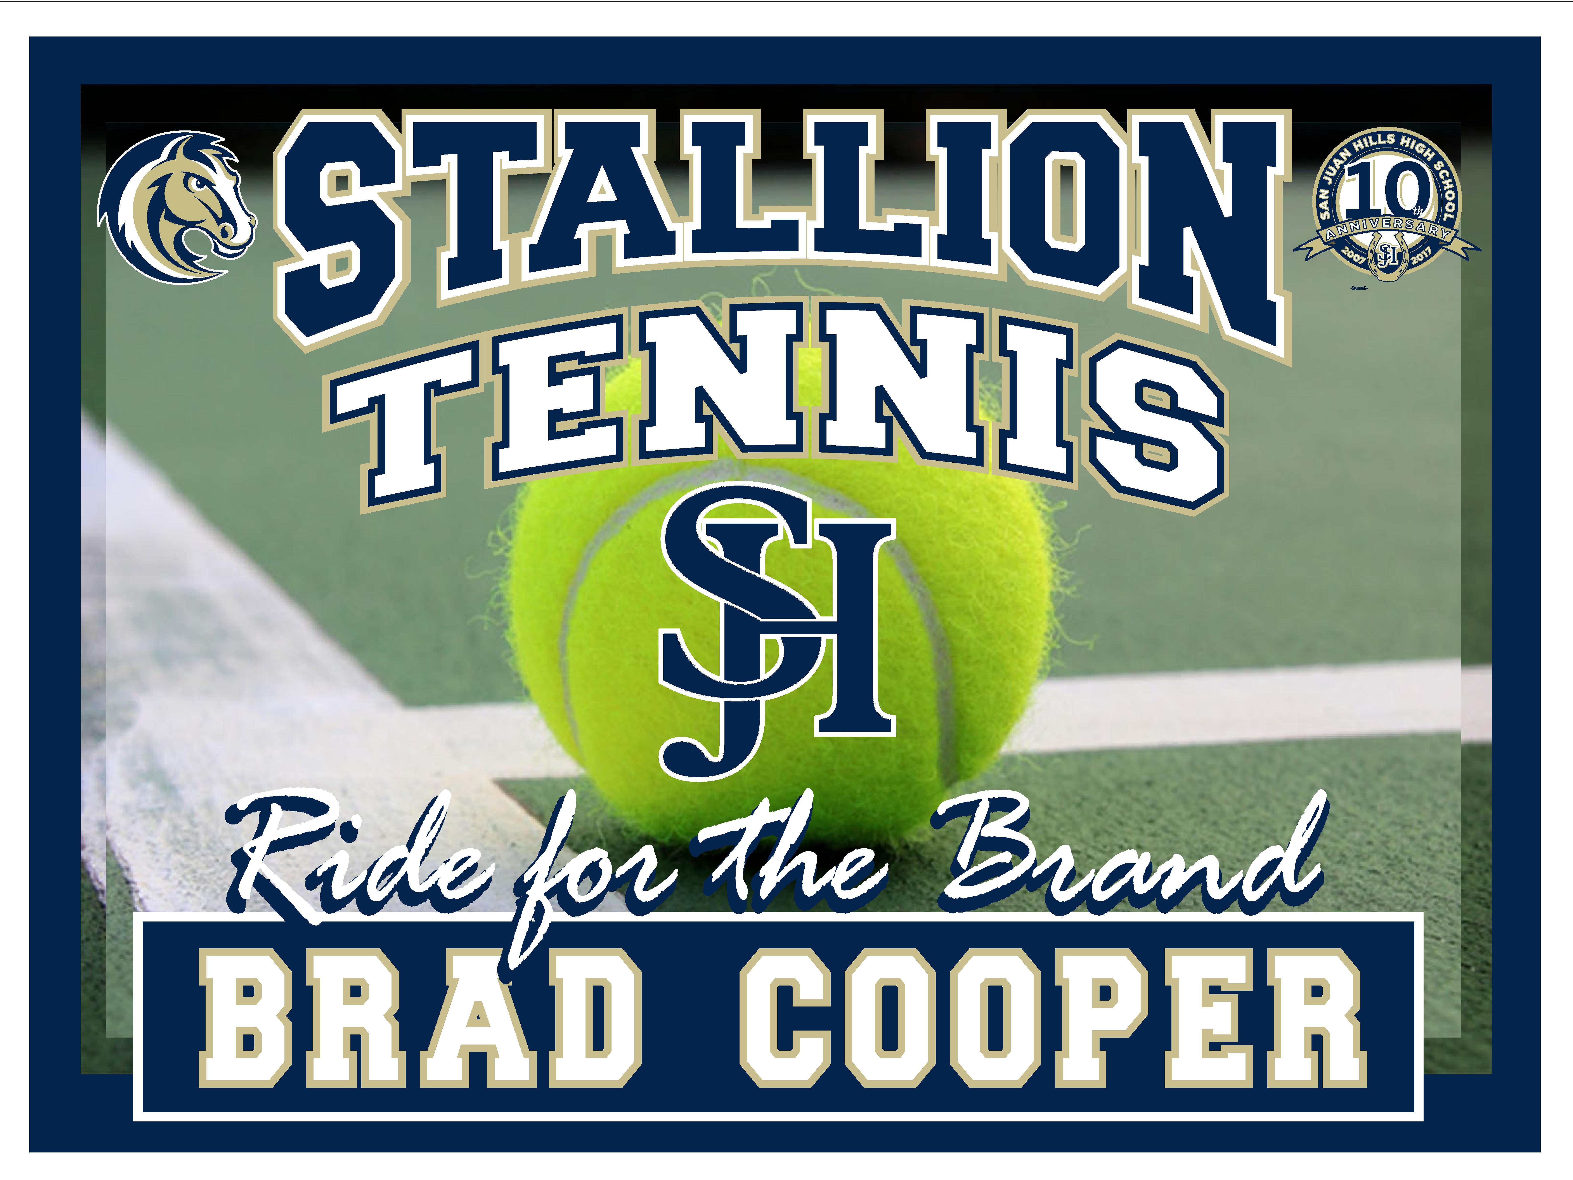
customize your sign with your student’s player #
$18 without Name
or
$23 w/ custom name

Vinyl Yard Sign features:
- Free personalization!
- Durable weather resistant coroplast
- Yard sign is single sided.
- Measures 18 inches high x 24 inches wide.
- Includes metal stake.
- Assembly required.

DEADLINE FOR TEAM ORDER IS August 30th, 2019
Turn in order forms to your Coach/team parent or to
front office at sjhhs!

Name_______________________________________ Cell #__________________________________________

Sign design (sport)__________________________ email____________________________________

Name on sign_______________________________ Player #_________________________________________

CK#_______________________________________ Cash____________________________________

cc (+1.00 fee) Credit Card # __________________________________________________________

Exp Date _______________ CSC #_________________ Zip _____________________________

Please make checks payable to: sjhhs ptsa
Questions: Debbie Bursey / sjhhsptsa@gmail.com
*not printed at cusd expense

